**Please use this form to complete your report. You can delete the text that describes each section, and replace the figures with your own graphs and pictures!   
(Don’t worry, any unused figures will be ignored)**

Team Name: Lamponi

Chosen theme: Life on Earth

Team members: Nicola Bortolotti, Matteo Bridi, Florian Giaffreda, Giulia Giaffreda

School**:** Coderdojo Trento

# Introduction

The main purpose of our experiment is to estimate the speed of the ISS using the OpenCV libraries through the analysis of the images of the Earth's surface.

Data from different sensors (like accelerometer and gyroscope) are collected in addition to the pictures so that, if the station’s settings are modified during the experiment (reboost, pitch, roll, yaw), it will be factored in during the data analysis to better calculate the speed from the images.

Estimated speed is later confronted with the real value to evaluate the goodness of our method.

We expect to see through the sensor data a steady station setting (unless programmed or rebooted operations) with a constant pitch of 4°/min. We furthermore expect to obtain a good approximation of the speed by analyzing the daytime images with a clear sky, in which it will be easier to recognize elements of the Earth's surface.

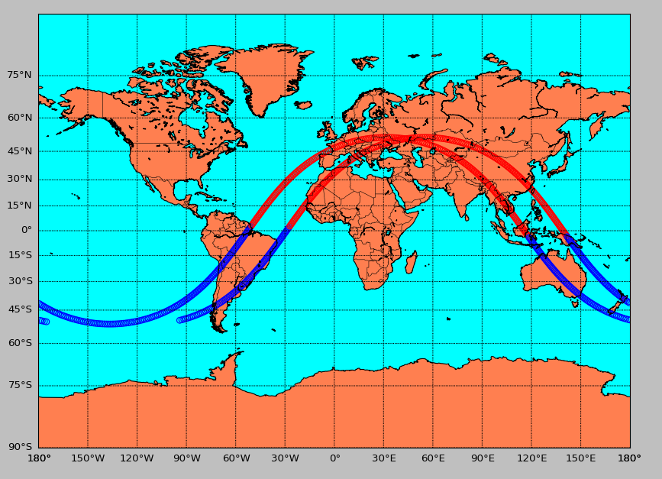

**Figure 1: ISS path during the experiment**

# Method

Through a python script we took a picture every 13 seconds, that is the time range that allows us to recognize the same points of reference on several consecutive images. In this way we got about 800 images during the 2 orbits (3 hours long experiment).

With the same program we collected the data of the sensors of the Sense Hat of the AstroPi that we associated to the images through the timestamp. We imported this data to a spreadsheet and created graphs to study their progress and to identify possible corrections to be applied to the images’s analysis. Using real literature data of the ISS we obtained the height of the station for each picture.

Another python program analyzed the images two by two by identifying the points that have a match (between the two images) and by finding the distance in pixels between those points.

After selecting the pictures with enough matching points (night images couldn’t satisfy the requirements because of the few correspondences), we calculated the speed of the station during its orbit through the data in our possession like: distance between the matching points, ISS height, interval photographs, camera features.

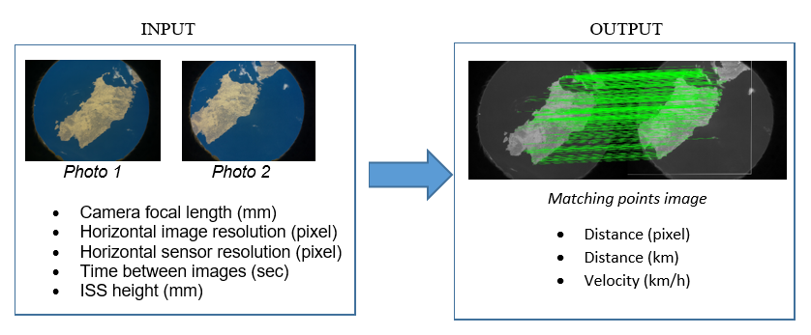

**Figure2: Algorithm input and output**

# Results

Analyzing the graphs of the sensors we detected a rotation of 360° on the pitch axis for each orbit. This movement allows the ISS to keep the same side facing the Earth during its orbital period. We read this value on the yaw axis of the RaspberryPI rather than on the pitch axis, probably because the Sense Hat’s position was rotated compared to the reference system of the ISS leading us to a situation were:  
Yaw (SenseHat) = Pitch (ISS)

At 08.43 a.m. of April 22nd we noticed a slight variation of roll and yaw. By consulting the ISS logbooks (https://blogs.nasa.gov/stationreport) we could not attribute this movement to some particular activities. At that time the ISS was in the dark, so the images do not allow us to identify any movements. Unfortunately we do not know if it is an error in the acquisition of the data or if it is a real maneuver.

From the analysis of the 818 images collected, 398 were discarded because they were taken at night and 37 others because they did not have enough points of reference.

On the 383 remaining images (corresponding to the diurnal interval of the two orbits) we recorded an average of 3663 points of reference, that allowed us to calculate an average speed of 25.968 km/h (compared to a real average speed obtained from TLE files of 27.615 km/h).

We examined in depths the analysis to try to improve our interpretation of the data by checking the goodness of the parameters we set. For example we measured the known distances in the pictures (the size of the Island of Sardinia) to verify the accuracy of the pixel/km conversion.

Ultimately we realized we calculated the traveled distance that is projected on the Earth’s surface, not at the real station’s altitude. Using the average terrestrial radius (6371 km) we calculated the real space traveled by the ISS along its orbit (figure 4) which is 6.3% higher than the distance at the surface level.

Using this value we obtained an average speed of 27.627 km/h, thus correcting our error.

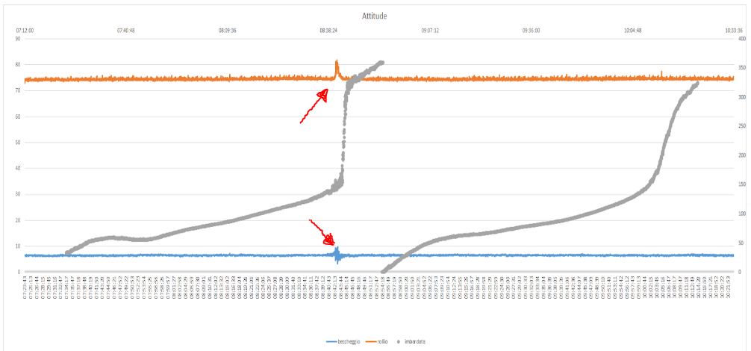

**Figure 3: Sensors values (pitch, roll, yaw) with the anomaly @22.04.2018 08:43**

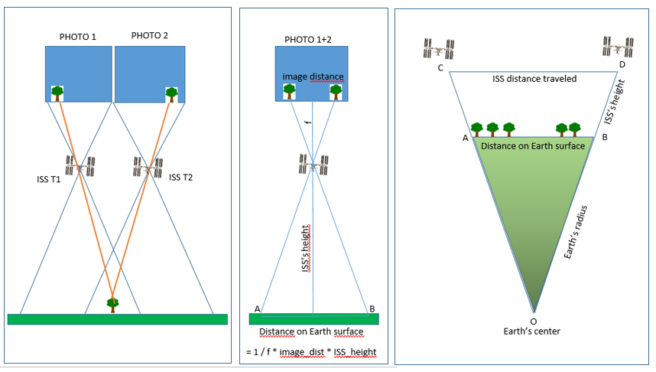

**Figure 4: image shift->earth shift-> ISS shift**

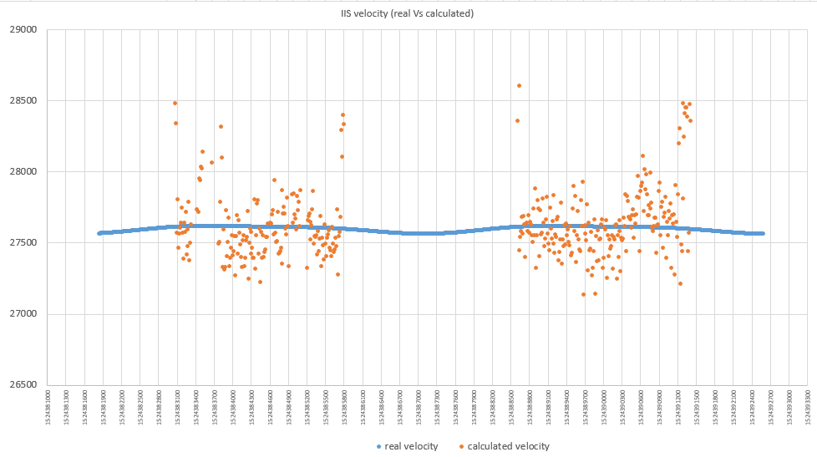

**Figure 5: ISS velocity (real vs calculated)**

# Conclusion

The experiment was successful because we were able to estimate the average speed of the ISS with a very high precision in the considered interval (average estimated speed 27.627 km/h, average real speed 27.615 km/h).

Unfortunately the sensitivity of PiCam did not allow us to find points of correspondence in night images, preventing us from obtaining a graph of velocity progress during the entire orbit. From these data we could perhaps observe an increase in speed near the perigee.

The sensor data surprised us a little: we expected a constant variation of the pitch (4 °/min) while from the graph we notice a non-linear trend that we could not explain (even if during an orbit we have a total of 360° of rotation as we expected).

Given the excellent results in calculating the speed from the analysis of the pictures, we think that we are going to use the same approach, the same programs and experience in the future, to calculate through a camera the speed of a car on the Earth, or of the robots that we use in the coderdojo.

We would like to thank the ESA for giving us the opportunity to analyze the data coming from that precious and distant laboratory that is the ISS and for letting us feel the emotion of being young scientists.

The scripts used, the raw images, the processed images and the details of the work done are available at https://github.com/CoderDojoTrento/AstroPi_2017-18.

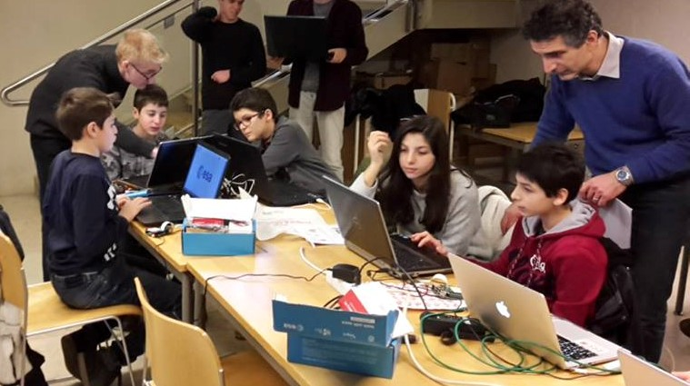

**Figure 6: Team Lamponi at work**